Name:G.sheshagiri

Reg.no:192111498

Code:CSA0726

**COMPUTER NETWORKS**

20.Simulate a Multimedia Network

step1:-first take switch

step2:-link that switch with 3 pc’s and after connect it with printer

step3:-connect that pc’s with the switch and the switch to printer

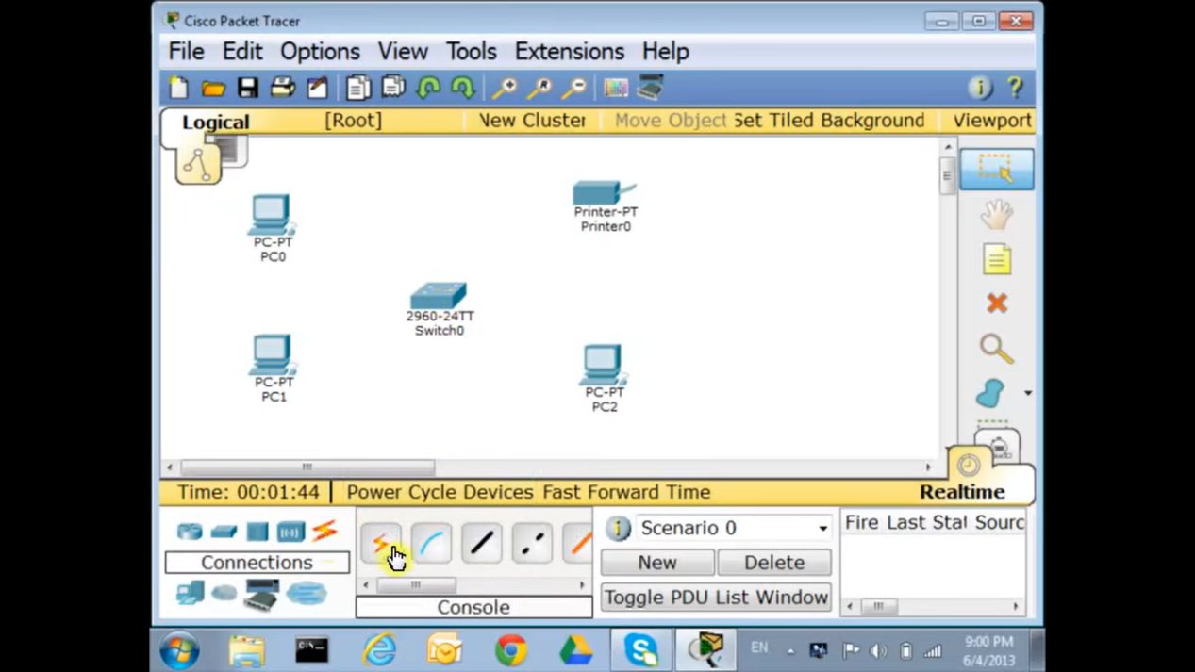

step4:- after connection check the IP address of the all pc’s in the config

step5:- if command send correctly you got successfull other wise recheck the connections

Step6:- then a Multimedia network was stimulated in packet tracer .

